IDEMPOTENCY-KEY COLLISION CHECK
Reliability Test Note — Fictional API Retry Trace
1. Executive Summary
A small Python checker was used to review a fictional API retry trace for unsafe reuse of idempotency keys. The test successfully identified one legitimate retry where the same key was reused with the same request payload, and one deliberate collision where the same key was reused with different request data.
Overall result: REVIEW REQUIRED. The collision condition was detected as intended and should be investigated before treating the trace as reliability-safe.
2. What Was Tested
The test contained eight fictional API events covering an initial request, a timeout, a valid retry, normal request activity and a deliberate same-key/different-payload collision.
No live API calls, production logs or production data were used. The purpose was to verify that the checker can distinguish a safe retry from unsafe reuse of an idempotency key.
3. How the Checker Works
The checker records the request payload associated with each idempotency key. When the same key appears again as a request or retry, the new payload is compared with the original.
Same key + same payload = SAFE RETRY. Same key + different payload = COLLISION. Timeout and response events are retained for trace context but are not treated as new requests.
4. Event-by-Event Results
Event | Type | Key | Finding | Interpretation
1 | request_sent | pay-001 | FIRST_USE | New key
2 | timeout | pay-001 | TRACE_EVENT | Trace context only
3 | retry_sent | pay-001 | SAFE_RETRY | Same key + same payload
4 | response_received | pay-001 | TRACE_EVENT | Trace context only
5 | request_sent | profile-002 | FIRST_USE | New key
6 | response_received | profile-002 | TRACE_EVENT | Trace context only
7 | request_sent | pay-001 | COLLISION | Same key + different payload
8 | response_received | pay-001 | TRACE_EVENT | Trace context only
5. Test Findings at a Glance
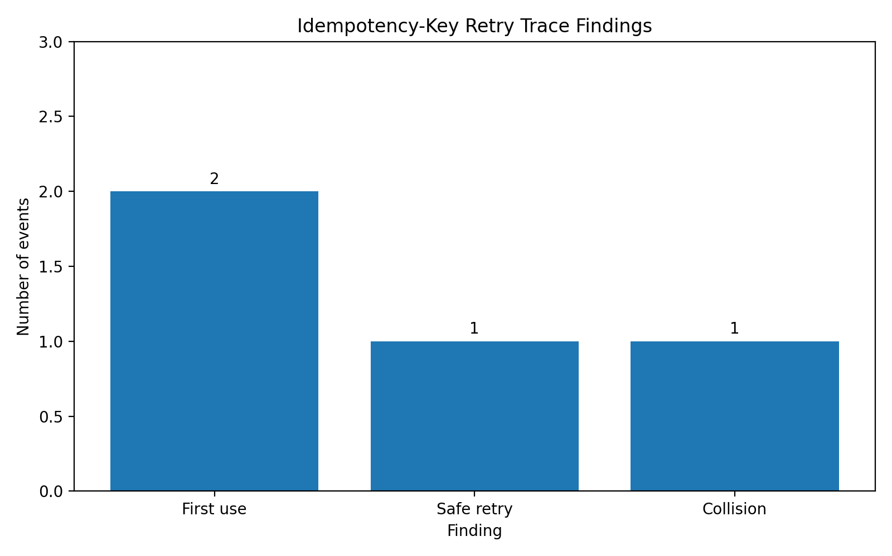
The checker classified 2 event(s) as first use, 1 as safe retries, and 1 as collision(s). 4 additional events were retained as timeout/response trace context.
6. Collision Detail
Key 'pay-001' was originally associated with event 1. At event 7, the same key was reused with different request data.
Idempotency key | Original value | New value | Changed field
pay-001 | 100 | 500 | amount
7. Why This Matters
An idempotency key is intended to identify one logical operation across retries. Reusing that key with different request data creates ambiguity about which operation the key represents.
In a real API environment, this could result in rejected requests, incorrect deduplication or inconsistent application behaviour, depending on how the API implements idempotency. The checker therefore treats same-key/different-payload reuse as a reliability risk rather than assuming that it is a normal retry.
8. Recommendation
REVIEW REQUIRED. The prototype correctly detected the deliberate collision. The affected key and request sequence should be investigated before considering the behaviour safe.
The checker is suitable as a local trace-analysis prototype. Before production use, it should be tested against additional cases such as multiple retries, missing keys, malformed payloads, different field ordering and repeated collisions.
9. Scope and Limitations
This exercise analyses a small fictional trace locally. It does not call an API, modify application data or validate the behaviour of a real production idempotency implementation. The findings demonstrate the checker's detection logic rather than a production incident.

